**AOOP PROJECT**

**Library Management System**

The **Library Management System** (LMS) is designed to modernize and simplify the operations of a library by addressing the common challenges faced by both librarians and students. These challenges include difficulties in finding available books, managing book checkouts, and avoiding overdue fines. By adopting a design thinking approach, the system focuses on understanding the users’ needs and improving the library experience. Key features such as online book search, real-time availability updates, book reservation options, and automatic notifications for book returns and overdue fines are introduced to enhance usability and efficiency.

**Problem Statement:**

The **Library Management System** aims to streamline the process of managing book inventories, borrowing records, and overdue notifications. Libraries face challenges such as inefficient book searches, manual tracking of availability, and overdue management. This system allows users to search for books, view real-time availability, reserve books, and track their borrowing history, while also providing overdue notifications to avoid fines. It enhances both user experience and librarian efficiency by automating key tasks and offering an easy-to-use interface for managing library operations.

**Objective:**

The goal of this project is to develop an online **Library Management System** that provides an easy-to-use interface for both librarians and users. The system will enable users to search for books, view real-time availability, reserve books, and track their borrowing history. Additionally, it will notify users about overdue books, helping them avoid fines. For administrators (librarians), it will streamline book management and provide tools to manage inventory, borrowing records, and overdue notifications.

**Group Members:**

T Varshith Swamy – 2320030196

T Sai Harsha - 2320030308

B Sri Hari - 2320030300

**System Design & Flow Chart:**

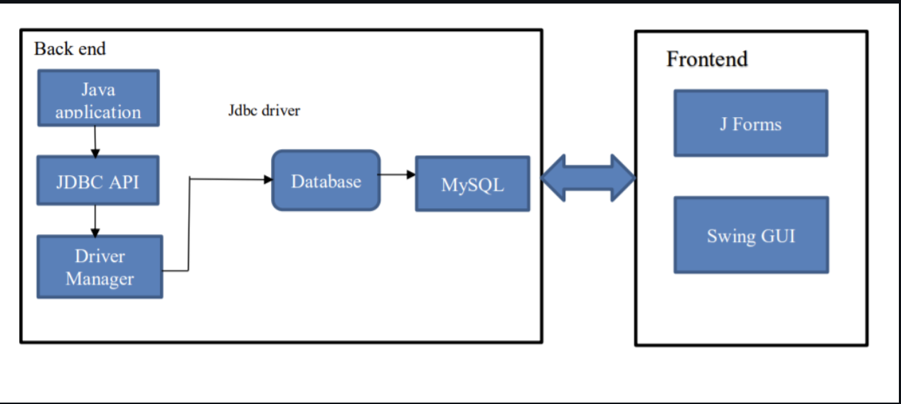

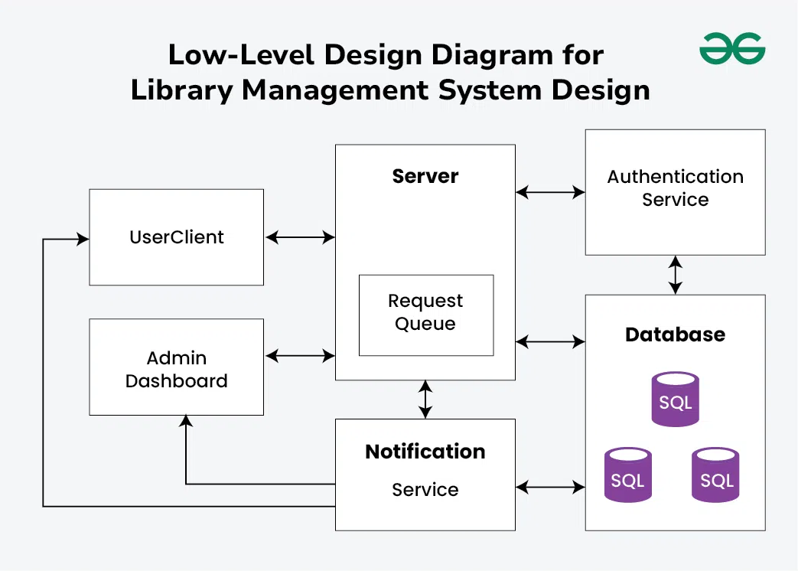

**System Requirements:**

Interpreters: Java and Java Database Connectivity(JDBC).

Software: Netbeans, Xampp.

Database: MySQL.

 Hardware: 10GB storage, 4gb ram 4.1.2

**Conclusion :**

In conclusion, the **Library Management System** provides an efficient solution for both users and librarians by automating key library operations such as book searches, reservations, and overdue management. By offering features like real-time availability, borrowing history tracking, and notifications, the system improves the user experience and simplifies the management of book inventories and borrowing records. This project addresses common library challenges, making the process more seamless, reducing manual effort, and ensuring timely returns to enhance overall library efficiency.

**References:**

<https://dev.mysql.com/doc/>

<https://tomcat.apache.org/tomcat-9.0-doc/index.html>

<https://docs.oracle.com/javase/tutorial/jdbc/>